CCCM Cluster Iraq Transition Strategy
Update: August 2022

Contents
Context 2
CCCM Cluster transition overview 5
1. Cluster coordination transition 6
2. CCCM operational response transition 9
3. Overall longer-term planning in camps and informal sites 10
Timeline of key decisions & planning 13

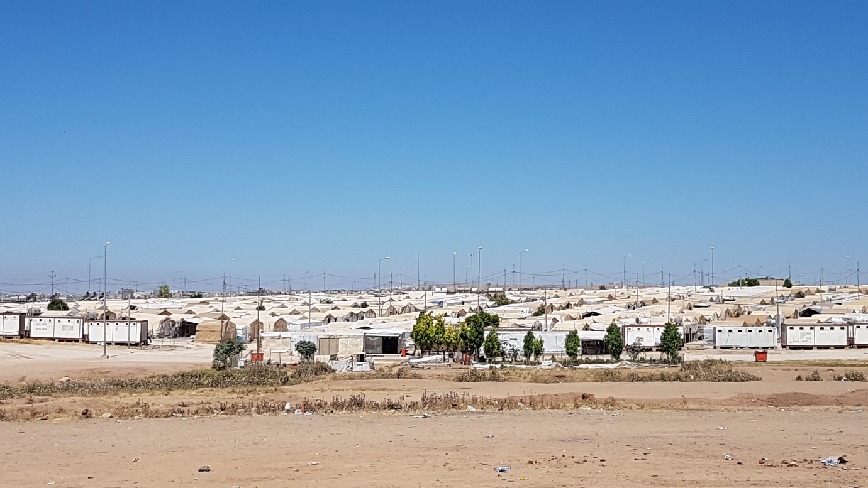
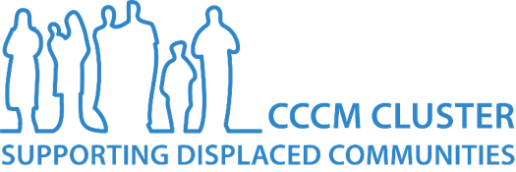

Context
Overview of transition context
The CCCM Cluster was activated in Iraq in mid-2014 as part of the Level 3 humanitarian response to the ISIL crisis. The crisis started in 2013, with major population displacements happening from mid-2014 onwards, and officially ended with the military defeat of ISIL in Mosul in December 2017. Over 6 million people were internally displaced in Iraq. At their height in 2017, 135 formal IDP camps were open across Iraq, with over 800,000 people displaced into camps and many more into informal sites. Considerable efforts have been made by the Government of Iraq with support of international actors to promote and support reconstruction and returns, with substantial rehabilitation of housing, reinstatement of services, and mine clearance in areas of origin.
By 2019, the humanitarian situation in Iraq had considerably improved, in parallel with improvement in the security and economic crises that resulted from the conflict. At the start of 2020, 1.4 million people were still displaced, of whom 280,000 were living in 67 IDP camps. A scale-down and exit of the Inter-Agency Standing Committee mechanisms supporting collective international humanitarian action in Iraq was being initially discussed, while recovery and durable solutions work was being upscaled.
On the direction of the Humanitarian Coordinator, the activities included in the 2020 Humanitarian Response Plan (HRP) were narrowed, with activities deemed to be “durable solutions” in nature removed from the HRP as a humanitarian document. This narrowing of activities was repeated in the 2021 HRP, removing, for example, reconstruction of highly damaged housing (being undertaken by recovery and development actors), and, for CCCM, the removal of the Community Resource Centre (CRC) modality in return areas.
The 2020 HRP was anticipated to be the last, and in August 2020 all Clusters were requested to draft an initial outline of a transition strategy. However, the COVID-19 pandemic and resultant economic impact and exacerbation of humanitarian need, and political situation in Iraq, meant that an HRP was drafted for 2021 and again for 2022. The discussion on the end to whole-of-system humanitarian response and deactivation of the IASC coordination mechanisms supporting this was paused. With humanitarian funding steadily decreasing, these discussions on humanitarian system transition resumed at the end of 2021 when the impact of COVID-19 had stabilized.
In February 2022, each Cluster was requested to submit to the HCT a first outline of a transition plan. In March 2022, the HCT made the official decision that “The system-wide international humanitarian response in Iraq will transition in 2022, with a view to hand over or simply exit most components of the joint response by 31 December 2022”. This included transition/deactivation of all Clusters by end 2022.
The overall humanitarian transition comprises two components: coordination and operational transition. Transition of the coordination system (deactivation of the Clusters, ceasing of HRP) has been the main focus of the overall transition discussion within the humanitarian system. On operational transition, strong messaging has been delivered by the HC and UN heads of agency to the Government of Iraq on the scale-down of humanitarian actor presence in Iraq, and the need for government to take over necessary services. In parallel to the individual Clusters working on transition implementation, OCHA presence was significantly downscaled mid-2022, with therefore a reduction in inter-cluster coordination and work at national and governorate level. OCHA will transfer into being a Humanitarian Advisory Team from 2023 onwards, with some staff maintained until mid-2023 to support field- and durable solutions coordination transition.

Durable solutions coordination
A separate coordination architecture for durable solutions has been established in Iraq, under the RC/HC, bringing together humanitarian, development, stabilization, and peace-building actors and programming. Work towards durable solutions was also included as a separate pillar in the UN Strategic Development Cooperation Framework for Iraq for 2020-2024.
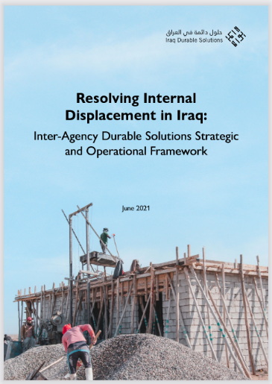
At national level, the Cluster Lead Agency and Co-Chair Agency (CLAs) sit in the Durable Solutions Taskforce (co-chaired by IOM) and are represented in the Durable Solutions Technical Working Group (also co-chaired by IOM). In addition, eight Area-Based Coordination (ABC) groups have been established in return areas – areas directly impacted by the conflict with high numbers of returned families and destruction of infrastructure and shelter. The ABCs are comprised of humanitarian, development, stabilization, and peace-building actors working at local level, aiming to work with local government to identify priority locations and interventions and develop Plans of Action (PoAs).
The areas covered by the ABCs include some – but not all – IDP informal site priority locations identified by the CCCM Cluster, but do not currently cover or specifically include families still displaced in camps.
Inter-Agency Durable Solutions Strategic and Operational Framework[LINK]

Durable solutions coordination architecture in Iraq
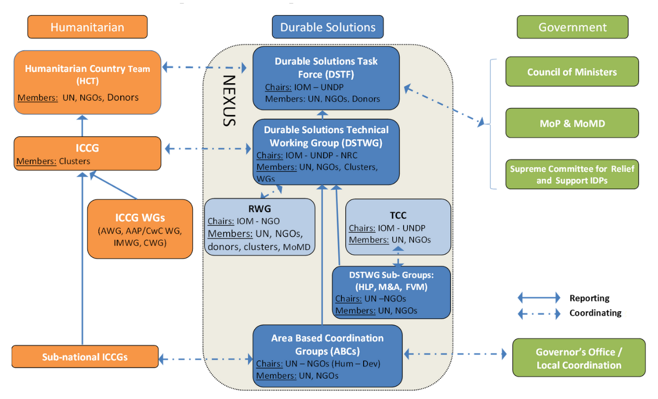
Figure 1: ICCG – Inter-Cluster Coordination Group (comprising Cluster Coordinators at national level, and Cluster Focal Points at governorate level), TCC – Technical Coordination Committee (focusing on families with perceived affiliation to extremist groups), MoP – Ministry of Planning, MoMD - Ministry of Migration and Displacement

Displacement situation in camps and informal sites

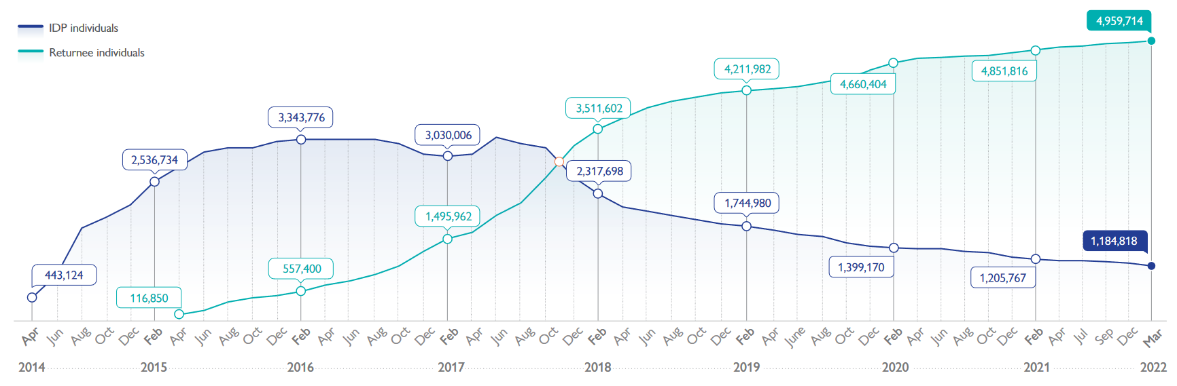
Since 2014:
>6M IDPs
>800,000 IDPs in camps

Mid-2022:
1.2M IDPs
180,000 IDPs in 26 camps
103,000 IDPs in 477 informal sites
# IDPs & returnees (2014-2022) [IOM-DTM]
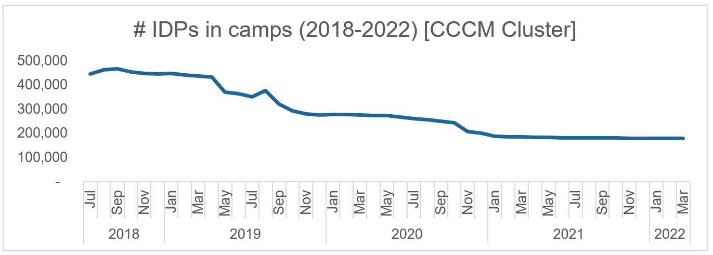

2022 CCCM response (mid-year status)
- Camps: 26 formal camps hosting 180,000 individuals are still open. 25 in the Kurdistan Region of Iraq (KRI) supported by UNHCR, 1 in federal Iraq managed by IOM. Camp management is implemented directly by IOM in the federal Iraq camp. In KRI, UNHCR funds the government for camp management and camp administration of the 25 camps and provides a camp coordination support function at governorate level through UNHCR Field teams. Both agencies are committed to continuing camp management support into 2023.

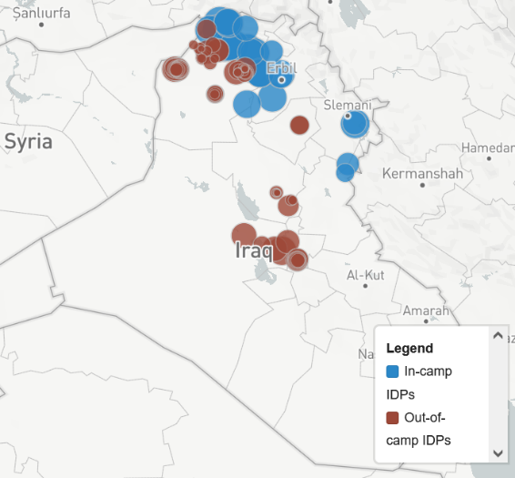
- Informal sites: CCCM partners (IOM, DRC, ACTED) are working in 73 informal sites all in federal Iraq, reaching 42,000 individuals as of July 2022 (40% of estimated total informal site population, and all highest-priority locations identified by CCCM Cluster & partners). Response is mostly through mobile CCCM teams, with static teams in the largest sites. Some funding is committed into 2023, and partners are working on phase-out or longer-term planning for sites that need continued assistance.

- Assessment: REACH conducts a camp profiling and intentions survey annually in all formal camps, and an annual informal sites assessment, in complement to the Cluster IM work.
# IDPs reached with CCCM response, 2022

As of June 2022, 90% of the CCCM 2022 HRP target number of individuals has been reached (100% of the in-camp target, and 60% of the informal site target).

CCCM Cluster transition overview
Since late 2019, five years after major displacements started and two years after the official defeat of ISIL and subsequent mass return movements, the CCCM Cluster has been gradually developing transition and phase-out plans from both CCCM operations and coordination.
This process has involved extensive discussions and consultations with CCCM partners, the Cluster Lead Agency and Co-Chair agency (CLAs), donors, other Clusters, and durable solutions coordinators, to understand the following:
- CCCM partner program planning, funding, development of exit strategies or plans for continued implementation
- CCCM partner priorities and concerns for continued coordination after the Cluster system deactivates, and partner capacities to take on governorate coordination
- Donor planning, and advocacy with donors for continued inclusion of informal sites CCCM response in remaining humanitarian funding into 2023
- CLA priorities

In early 2022, the Cluster finalized its transition approach – building on previous work. At the time of this update in July 2022, the Cluster is process of implementation of a transition plan, working towards deactivating the Cluster by the end of 2022.

Three aspects of transition are of concern to the CCCM Cluster:
- Cluster (coordination) transition
- CCCM operational response transition & forward planning
- Supporting overall operational humanitarian response transition & longer-term planning in camps and informal sites

CCCM Cluster transition timeline, 2022
 | Q1&2 | Q3 | Q4
Cluster coordination | Cluster coordination transition strategy agreed with CCCM partners | Transition of informal site governorate-level CCCM focal points | Full coordination transition to CLAs / CCCM partners
Camps | Camp Roadmap drafted & agreed | Engagement with stakeholders on camp roadmap implementation | Camp roadmap implementation, monitoring of services handover impact
Informal sites | Informal Site Roadmap drafted. Identification of highest-priority informal sites. Start of drafting of site-level plans | Continuation of drafting site-level plans for highest-priority sites, and engagement with Durable Solutions coordination & actors | Implementation of site-plans. Operational planning for remaining 2023 CCCM informal site support.

Cluster coordination transition
For the remaining camps open in Iraq, by circumstance a clear trajectory for the transition of Cluster coordination functions emerged. For the remaining camps, the relevant functions of the CCCM Cluster will be absorbed by UNHCR and IOM, depending on the camp. For informal sites, CCCM UN and INGO partners will engage directly in coordination at local level – particularly with durable solutions mechanisms.
Until the closure of almost all remaining federal Iraq camps in late 2020, the camps had varied management structures across Iraq: direct management by INGOs and NNGOs, direct management by UN agencies, or government management with CCCM support from NGOs and UN agencies. The first outline of a potential CCCM Cluster strategy in mid-2020 anticipated engagement of the federal Iraq government body responsible for the IDP displacement portfolio in Cluster transition. However, following the sudden closures the remaining 26 IDP camps are supported only by UNHCR (25 camps in KRI, UNHCR supports government management) and IOM (1 camp in federal Iraq directly managed by IOM). Both agencies already perform the camp coordination as well as camp management functions, and both plan to continue operational CCCM interventions as needed.
2020 note on CCCM Cluster transition
In informal sites, IOM is the largest CCCM actor, with strong INGO partners (ACTED and DRC) already engaged in coordination at governorate and national level. In addition, IOM co-leads the durable solutions coordination and has substantial durable solutions program implementation, providing a clear point of synergy and point of integration of informal sites response into durable solutions planning.
IASC Cluster core functions, and planned transition modality
Cluster Core Functions | Iraq CCCM Cluster modality of transition
Supporting Service Delivery | Internalized within CLAs & operational CCCM partners
Informing humanitarian strategic decision making | Performed by CLAs
Planning and strategy development | Internalized within CLAs
Advocacy to address identified needs | Performed by CLAs
Monitoring and reporting on cluster strategy | N/A
Contingency planning | Internalized within CLAs

Camps: 25 KRI-administrated camps: UNHCR internalizes the relevant functions of the Cluster
- At governorate level:
  - The ‘Camp Coordination’ function of UNHCR Field Office staff (currently, as Cluster Focal Points) will continue, supporting the governorate body (DMCR) in cross-camp coordination, planning, strategic decision-making – aiming for DMCR to lead, with UNHCR support as needed
  - UNHCR Field Offices will continue existing work supporting camp management
  - Existing governorate-level Camp Coordination meetings co-chaired by DMCR and UNHCR continue, bringing together partners, sectoral focal points (if continuing), & relevant local authority service providers. Camp Coordination meetings able to absorb some functions of governorate-level Clusters and ICCGs relevant to camps.
- At KRI (cross-governorate) level
  - UNHCR will introduce a new internal CCCM Officer position, to work with UNHCR Field Offices to support future CCCM transition and overall camp transition planning
- At national level
  - UNHCR senior leadership will engage in necessary strategic planning and advocacy

Camps: Jeddah 5, federal Iraq: IOM maintains camp management and broader leadership role
- At governorate level:
  - IOM CCCM will take on external coordination functions currently provided by the Cluster in any remaining humanitarian coordination forums
- At national level:
  - IOM senior leadership and CCCM will engage in strategic planning and advocacy
Informal sites: IOM, ACTED, DRC direct engagement in coordination
- At governorate level:
  - CCCM governorate focal point responsibilities will be transferred to CCCM partners continue programming into 2023
Governorate coordination guide
  - CCCM partners will engage directly in any remaining governorate-level humanitarian coordination forums, and continue their engagement in ABCs where present
  - A guidance note on coordination responsibilities has been drafted with partners
- At national level:
  - Informal coordination between the three operational CCCM partners will continue
  - Support of DSTWG to ensure informal sites are included in ABC Plans of Action
  - Unresolved critical issues will be raised to the HCT at national level through the Cluster Co-Coordinator in 2022, through OCHA to mid-2023, or through individual organizational representation, and/or to the DSTWG through ABCs, and individual organizational representation.

Cluster information management
Cluster IM transition strategy
The CCCM Cluster IM team has been working since mid-2021 to rationalize and downscale Cluster IM products and processes, anticipating the Cluster transition. A separate IM transition strategy has been drafted. The following are the remaining regular IM process and products conducted by the CCCM Cluster, transition for which is described in more detail in the strategy:
Tools & products | Transition plan
HRP monitoring & reporting | Stops at end of 2022, with end of HRP
Camp Population Masterlist & products (monthly) | Transition to UNHCR IM for 25 KRI camps & IOM IM for 1 federal Iraq camp
Formal Site Monitoring Tool | Not conducted so far in 2022. Responsibility transitioned to UNHCR & IOM.
Camp Exit Survey | Tools to be handed over to partners conducting the survey
Informal Sites Masterlist | Separate Cluster list phased out as of mid-2022, following with work IOM-DTM to instead integrate an informal sites list within the existing annual DTM Integrated Location Assessment

The Cluster files will be archived with UNHCR Iraq, and the Cluster website kept online in order that the past IM products and technical guidance can remain available.

Figure 2: Cluster staffing & focal points (coordination engagement) 2021-22
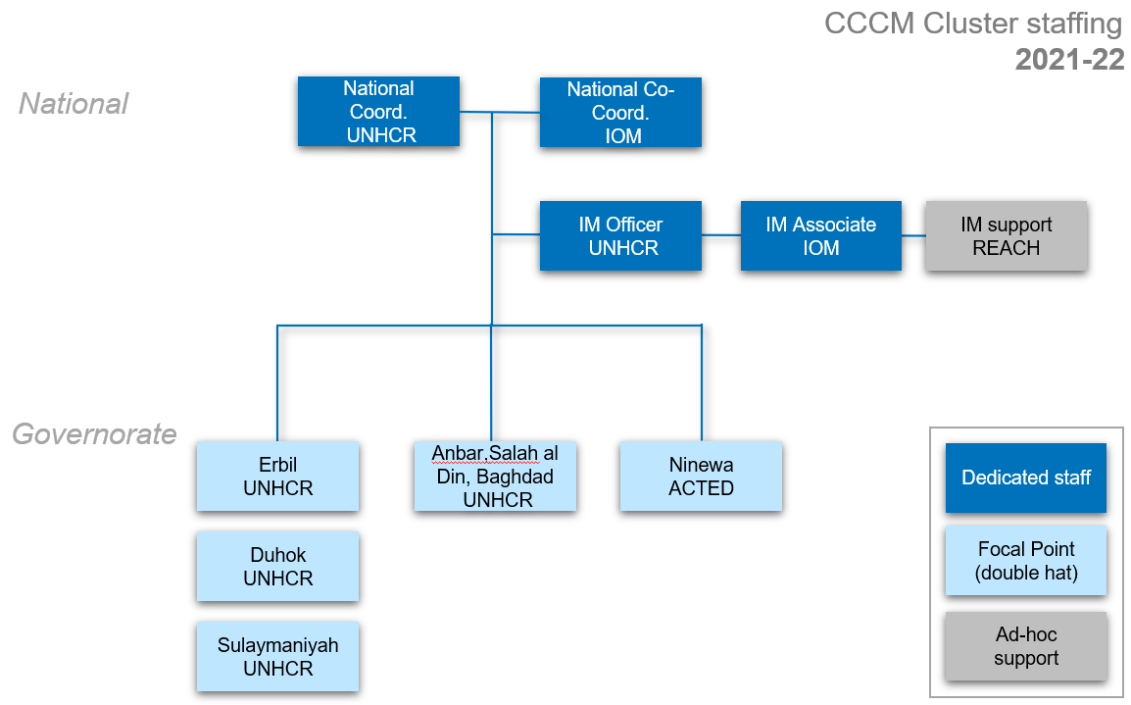

Figure 3: CCCM coordination engagement 2023 onwards
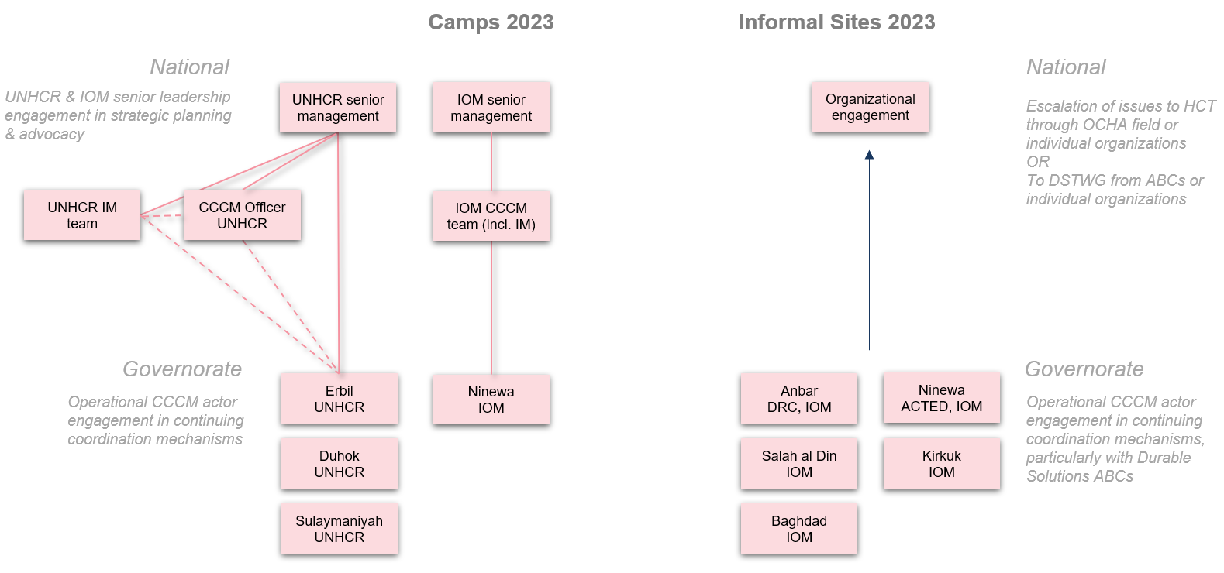

CCCM operational response transition
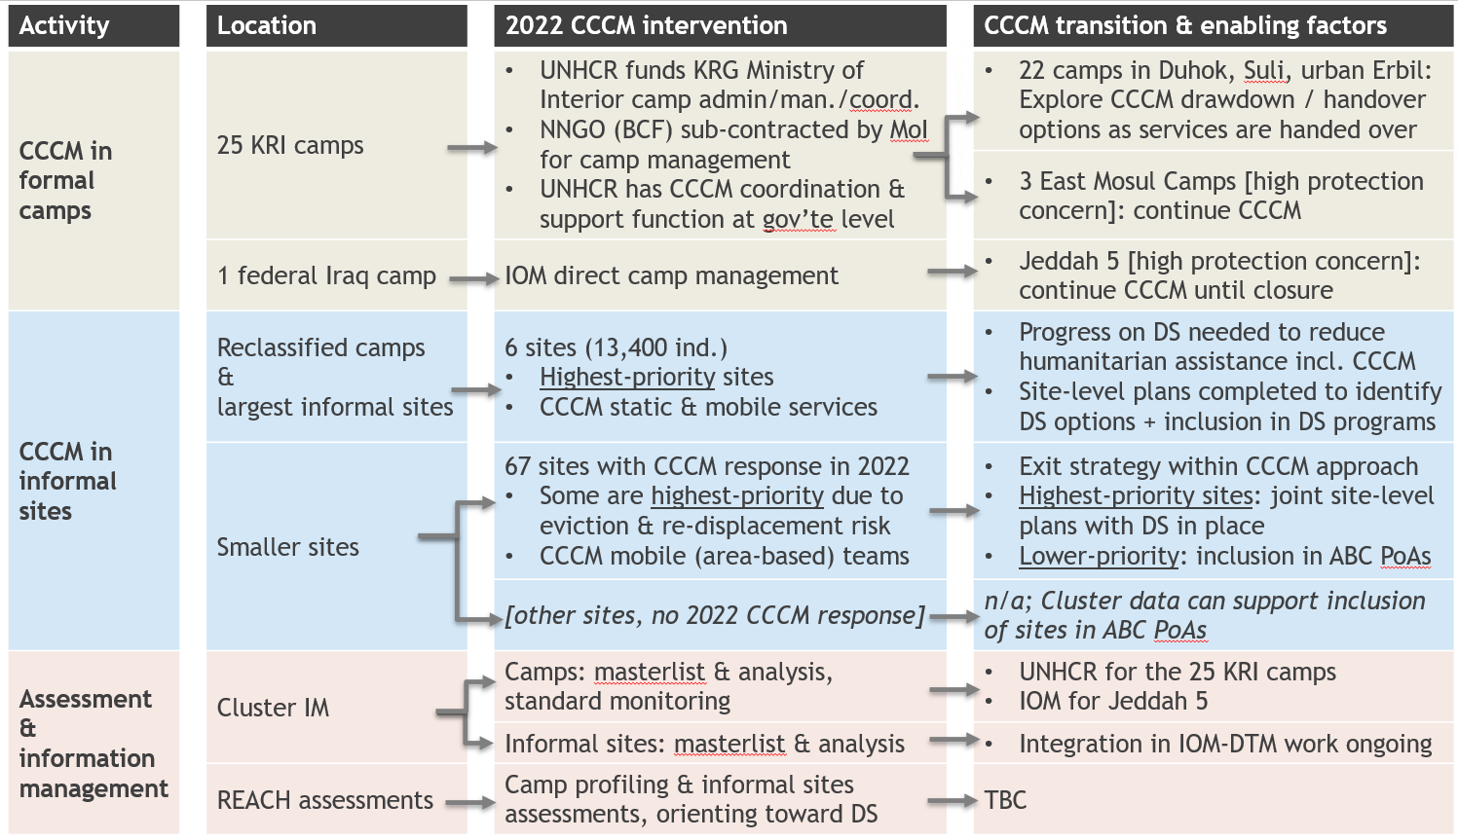
Overview

For camps, UNHCR and IOM will continue CCCM support into 2023. In the camps with significant protection concerns (Jeddah 5 and East Mosul Camps), humanitarian camp management will continue into 2023 and will need to continue until sustainable solutions are found for the families. For the other 22 camps, UNHCR will continue its CCCM commitments, exploring rationalization options going into 2023. Longer-term planning for CCCM/camp management will be made alongside progress on overall future planning for the camps, including options to gradually downscale and hand over responsibilities to government authorities and increase engagement of community representatives and committees.
In informal sites, CCCM response was prioritized by the Cluster in late 2019 and in the 2020 HRP. As part of this, a strategic approach was developed, aiming to implement time-bound interventions of up to 12 months with a clear exit strategy. The strategy aimed to improve basic standards in informal sites in the short- to medium-term and support IDPs to move towards self-reliance. Iraq CCCM Cluster Strategy for Transitional Support for Informal Sites [LINK].
Informal sites operational strategy 2019
Reference: informal sites CCCM activities transition strategy
Since late 2019, CCCM partners have been operating this time-bound intervention modality aiming to support sites and families towards longer-term stability and improved living situation where this has been appropriate for the site situation. In most informal sites that have CCCM response in 2022 going into 2023, this modality of intervention is being implemented – with the CCCM interventions designed for an exit of CCCM response. CCCM partners focus on: site safety works, advocacy on inclusion in municipal services, population and intentions data to inform response, supporting (sectoral) partners in transition / exit planning, community representatives capacity-building to interact with local authorities. In addition, CCCM partners have been working closely with durable solutions Area-Based Coordination (ABC) mechanisms, to ensure informal sites are included in durable solutions planning, and actors are aware of any remaining critical site issues including eviction risk.
However, in a few higher-priority locations, longer-term CCCM presence has been established. This includes the largest sites of several thousand people (Jebel Sinjar, Kilo 7), the former camps (AAF, HTC, Beizeibz), and sites with high protection concerns and eviction risk (Balad Train Station, Mosul city informal sites). In these, progress is needed towards durable solutions for families before humanitarian service provision, including CCCM, can reduce. Efforts of the Cluster and partners to work on solutions for these families – and, thus, an exit strategy for CCCM actors – are detailed below.
Assessments conducted by REACH are the final component of the CCCM response in Iraq, aiming to inform overall response planning for camps and informal sites. REACH currently conducts:
- Camp Profiling survey in each camp as part of the Multi-Cluster Needs Assessment
- Camp Intentions Survey in each camp, alongside the camp profiling
- Camp Infrastructure Maps update
- Informal Sites Assessment and Intentions Survey; in 2022, representative to sub-district level,
Decisions on REACH assessments in 2023 will be taken in the second half of 2022, based on humanitarian and durable solutions actor demand for data, and availability of funding.
- Camp profiling & intentions surveys: the CCCM Cluster recommends the continuation of this assessment, as a monitoring exercise especially given planned services handover in the camps. If there is no MCNA in 2023, the survey tools can likely be significantly reduced.
- Informal sites assessment: the REACH informal sites assessment currently uses sites identified in IOM-DTM annual Integrated Location Assessment’s Informal Sites Assessment; methodology of the assessment for 2023 would be pending IOM-DTM’s decision on a 2023 ILA

Overall longer-term planning in camps and informal sites
In addition to the delivery of CCCM response, the CCCM Cluster and CCCM partners have been working on and supporting longer-term planning and overall humanitarian transition in both camps and informal sites.
In March 2022, the Cluster with UNHCR and IOM drafted a Roadmap on Camps and Informal Sites, to be an addition to the overall HCT Transition Roadmap.
Camps & Informal Sites Roadmap
IDPs living in camps and informal sites continue to face significant barriers to return and to achieving other sustainable solutions, including: destroyed shelters and infrastructure, lack of security, tribal issues, perceived affiliation to extremist groups, areas being blocked for return, and lack of civil documentation. Returns intentions and preferences of families are varied. REACH annual intentions surveys in camps and informal sites provide data for forward-planning, complemented by periodic surveys by CCCM actors.
Camps
UNHCR was requested by the HCT in March 2022 to take a lead among international actors on the overall transition in the 25 KRI camps, and IOM has taken a leadership role in Jeddah 5 since its takeover of camp management in late 2020. The CCCM Cluster has been working with the two CLAs to develop longer-term planning.
Camp Roadmap Update, April 2022
Broadly, these efforts aim to work towards supporting families to leave the four camps with highest protection concerns, and in the remaining 22 camps, to work with families and KRG authorities to identify longer-term options, including in suitable camps where families wish to stay longer-term to work towards inclusion of the camps in municipal services.
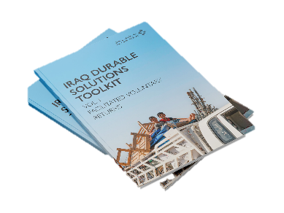
Jeddah 5 [high protection concern]: The Government of Iraq’s position is that all camps should be closed; the remaining camp in federal Iraq, Jeddah 5, has an agreement between international humanitarian actors and government authorities that international actors will work to support returns and resettlement of families, to enable future closure of the camp. IOM is implementing programming for both day-to-day management and to support families to leave the camp, including camp management, facilitated voluntary movements, and tribal reconciliation. These efforts to support families to return or relocate are supported by other humanitarian actors, and due to the agreement on closure, profile of families, and protection concerns, continued humanitarian service provision will be needed while the camp is still open.
Facilitated voluntary movement: IOM has been implementing a facilitated voluntary movement program in camps since 2020, first piloted in 2019, and now expanding to informal sites. The approach is detailed in a Toolkit, developed by IOM with the CCCM Cluster, Protection Cluster, UNHCR, IRC, DRC, and the Cash Working Group.
East Mosul Camps [high protection concern]: three camps in ‘East Mosul’, administrated by KRI’s Erbil Governorate, are of a similar high protection concern due to their location and the profile of some families living in the camps. UNHCR with IOM and the CCCM and Protection Clusters developed a Joint Strategy for the East Mosul Camps in the first half of 2022, outlining steps to be taken by these actors to support the identification of solutions for different groups of families in the camps. This includes suggested rollout of a facilitated movement program by IOM, with engagement commenced by UNHCR with KRG authorities on the future of the camps. Due to their isolated location and the high protection issues, continued humanitarian service provision will be needed while the camps are still open.
Remaining 22 KRI camps: The CCCM Cluster has been working with UNHCR and other Clusters to identify longer-term options by camp / group of camps – which differ by governorate, by area, and in some cases by camp. Tools being used for this include a camp services and infrastructure overview, mapping out service provision, land ownership, and camp infrastructure to identify camps that may be suitable for longer-term accommodation. In addition, a comprehensive mapping of remaining humanitarian services will be compiled by the CCCM Cluster in Q3 2022, detailing humanitarian actor funding and funding end-dates, handover/transition plans, and identifying services of concern where either handover is not possible or continued humanitarian support is needed.
Camp services & infrastructure overview
In Duhok, self-upgrading of shelters was approved by the Governor in June 2022, permitting IDPs to replace tents with concrete block or mud shelters. In these locations, where at least mid-term residence is anticipated, advocacy on inclusion of the camps in municipal services will be prioritized.
In Sulaymaniyah, the Cluster has been working with UNHCR to identify options for the camps in the medium-term, including for camp consolidation, given families living in the larger camps are mostly from areas where either return is blocked, or insecurity is high.
In Erbil, a Committee on Consolidation was formed by KRG authorities in early 2022. UNHCR will continue to engage with the authorities on future planning for all six camps administered by Erbil authorities, as well as working on specific issues for families living in the three East Mosul Camps.

Informal sites
CCCM partners and the Cluster have been working at national and governorate level to:
- Develop prioritization to identify informal sites of highest concern
- Work with durable solutions coordination to ensure informal sites are included in national durable solutions strategy and in local ABC Plans of Action
- Work with other humanitarian actors to support exit and transition/handover of services
IDPs still living in informal sites are typically vulnerable in profile, with mixed barriers to return and with risk factors related to poor living conditions and risk of re-displacement. WASH, protection, and shelter humanitarian interventions include informal sites in their targeting but they were not systematically included in early durable solutions conversations, which focused on return areas.
The following streams of work have been developed by the Cluster to support and encourage longer-term planning for the sites, both for humanitarian transition planning and inclusion in durable solutions planning and interventions.
Informal sites transition strategy
A specific strategy on informal sites CCCM transition was developed by the Cluster and CCCM partners. This strategy outlines the objectives, and actions achieved and planned, by CCCM partners and the CCCM Cluster, in the context of humanitarian transition and considering the persisting barriers to return for IDPs in informal sites. Designed in the format of a workplan, the strategy outlines:
- Operational actions being undertaken by CCCM partners to improve living conditions and access to services in informal sites and develop responsible CCCM exit strategies
Cluster Informal Sites Transition Strategy 2022
- Coordination engagement of CCCM partners to support site-level humanitarian transition and contribute to local durable solutions planning
- Coordination engagement and technical guidance of the CCCM Cluster and transition of coordination responsibilities
Analysis to support prioritization of informal sites
The Cluster has been working on a prioritization of informal sites going into humanitarian transition, to identify sites of most concern as the humanitarian response draws down. This builds on past analysis, including the HCT Informal Sites Note (February 2021), and ongoing CCCM and protection actor engagement particularly at governorate level.
Framework for Informal Sites Prioritization
This analysis is summarized in a Framework for Informal Sites Prioritization (Note on status of informal sites: Identifying characteristics and risks relating to options for longer-term solutions, January 2022).
It identifies three components of consideration:
Condition of site + Protection issues + Opportunities for people to return or integrate
The sites of highest concern are those where the three issues overlap, where a site has:
- Protection risks (including eviction risk)
- Poor site conditions including criticality of shelter
- Families are unable to return, local authorities are unwilling or unable to provide services in the site and/or provide alternative living options, and families are still reliant on humanitarian service provision to meet basic needs (especially for WASH services)
That is: sites of highest concern are those where families are unable to achieve any form of durable solution and are at risk of long-term exclusion. While durable solutions plans should and do include these sites, this analysis acknowledges that it will take some time for solutions to be found, during which time stopping humanitarian assistance risks significant deterioration of the situation for these families.
Durable Solutions Prioritization Matrix
Reference: DS prioritization matrix
Developed by the CCCM Cluster, CCCM partners working in informal sites, and durable solutions coordination. Designed to capture and summarize existing site-level data and information, summarizing it in line with durable solutions’ actors ways of working, aiming to support inclusion of informal sites in durable solutions planning and programming.
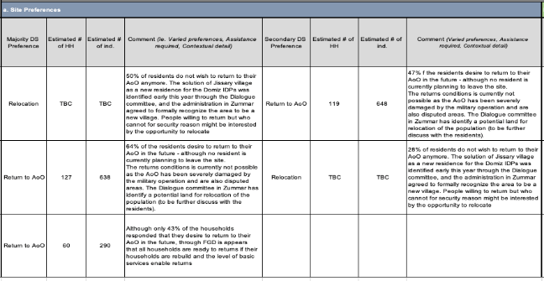
The matrix is in three parts:
i. Site Information
ii. Durable Solutions Profile
a. Site Preferences
b. Return Potential
c. Local Integration Potential
d. Relocation Potential
iii. Contact Details and Follow Up

Specific strategies for highest-priority sites
In complement to the DS Prioritization Matrix, the CCCM Cluster and CCCM partners are working to develop site- and location-specific strategies for highest-priority sites, particularly those where families are reliant on humanitarian service provision and have critical protection risks including risk of eviction.
As of August 2022, the strategy for Balad Train Station is under revision, a strategy for Anbar former camps and transitional/durable solutions sites being discussed, and a strategy for Jebel Sinjar in the preliminary stages.

Timeline of key decisions & planning
 | Overall response | CCCM Cluster
Nov 2019 |  | Strategy on transitional CCCM approaches for informal sites developed
Aug 2020 | All Clusters requested to draft a note on potential transition options; transition discussions then paused | First note on CCCM Cluster transition strategy drafted
Oct 2020 – Jan 2021 |  | Sudden closure and eviction of 16 camps and informal sites in federal Iraq by GoI, resulting in 43,000 individuals leaving camps, an estimated 1/3 being secondarily displaced.
Dec 2020 |  | CCCM Cluster hosts an informal sites discussion between Clusters, DS actors, CCCM partners on better linking humanitarian interventions plus durable solutions options. Little traction for follow-up built, although an HCT note on informal sites humanitarian response is issued.
Mid-2021 |  | CCCM Cluster coordination team starts to split work between informal sites (IOM staff) and camps (UNHCR), anticipating future Cluster transition
Feb 2022 | All Clusters submit a first outline of a transition plan, anticipating Cluster deactivation by end 2022 | CCCM Cluster transition strategy first version drafted, building on previous work  First informal site ‘Durable Solutions Prioritization matrix’ compiled, with CCCM partners & DS coordination
March 2022 | HCT Transition Roadmap drafted  HCT Retreat  - Official decision that “The system-wide international humanitarian response in Iraq will transition in 2022, with a view to hand over or simply exit most components of the joint response by 31 December 2022”  - Official decision that all Clusters will be deactivated by end 2022  - HCT Transition Roadmap de-facto adopted  - UNHCR requested to lead on overall humanitarian transition in 25 KRI camps | Includes Roadmap for Camps and Informal Sites, drafted by the CCCM Cluster with UNHCR & IOM
March – June 2022 | High-level messaging effort led by HC with Government of Iraq, communicating on decision to scale down and advocating for GoI to take over service provision
April 2022 | Transition Advisory Group formed. Decision that the HCT will remain into 2023
April 2022 | Clusters draft individual transition risk analysis | Update to Camp Roadmap drafted
June 2022 |  | CCCM Cluster Iraq Informal Site Working Transition Strategy released  Cluster IM transition strategy finalized
July 2022 | Official HCT decision that no 2023 HNO/HRP will be developed  Downscale of OCHA team, reduced inter-cluster coordination and work.  Decision that OCHA will transfer into a Humanitarian Advisory Team from 2023. | CCCM governorate-level coordination transitions to CCCM partners each directly engaging in coordination mechanisms, from Cluster focal points
August 2022 | HCT decision that a light 2023 humanitarian strategy document will be drafted, setting out main humanitarian needs (based on 2022 REACH MCNA), defining HCT’s recommended priorities for humanitarian actors and donors, reflecting on the state of transition, establishing priorities for HCT action in 2023. Strategy document will aspire to reflect/reference development and governmental commitments and collective outcomes.

The removal of the CRCs as a CCCM HRP activity was with the agreement of the CCCM Cluster and the CCCM partners implementing this response modality. The CRC modality was designed for areas with high numbers of people returning. By the end of 2020, with many people now back in their areas of origin for several years, the CRC modality was agreed to be more aligned with longer-term durable solutions/recovery programming than humanitarian response, and NGO partners were phasing out of the work. CRC implementation was continued by IOM as part of their durable solutions and recovery programming.
https://iraqdurablesolutions.net/Uploads/static/DS%20Operational%20and%20Strategic%20Framework%20Iraq.pdf
https://iraqdurablesolutions.net/
CCCM Cluster, Camp Population Masterlist June 2022 & CCCM partner reporting June 2022
IASC Reference Module for Cluster Coordination at Country Level, July 2015 [LINK]
Directorate of Migration, Displacement, and Crisis Response
https://data.unhcr.org/en/situations/iraq_cccm
https://data.unhcr.org/en/documents/details/84372
https://iraq.iom.int/sites/g/files/tmzbdl1316/files/documents/iraq-durable-solutions-toolkit-v03-report.pdf

